Jesus is announced as a king
- Throne of david his father
- Rule over jacob’s house
- no end to his kingdom
- see also Magnificat and account of Jesus’ birth in Luke 2

Fits with Luke’s relative emphasis on women in his story
- 42 passages in luke include women, 23 of these are unique to Luke
- 10 women are named in Luke’s story compared to 133 men (76 in the genealogy

Compare to Sarah’s story in Genesis and Hannah’s story in 1 Samuel 1.

Only luke includes this story
- No birth narratives in Mark and John
- Angel only appears to joseph in matthew

²⁶ When Elizabeth was six months pregnant, God sent the angel Gabriel to Nazareth, a city in Galilee, ²⁷ to a virgin who was engaged to a man named Joseph, a descendant of David’s house. The virgin’s name was Mary. ²⁸ When the angel came to her, he said, “Rejoice, favored one! The Lord is with you!” ²⁹ She was confused by these words and wondered what kind of greeting this might be. ³⁰ The angel said, “Don’t be afraid, Mary. God is honoring you. ³¹ Look! You will conceive and give birth to a son, and you will name him Jesus. ³² He will be great and he will be called the Son of the Most High. The Lord God will give him the throne of David his father. ³³ He will rule over Jacob’s house forever, and there will be no end to his kingdom.”
³⁴ Then Mary said to the angel, “How will this happen since I haven’t had sexual relations with a man?”
³⁵ The angel replied, “The Holy Spirit will come over you and the power of the Most High will overshadow you. Therefore, the one who is to be born will be holy. He will be called God’s Son. ³⁶ Look, even in her old age, your relative Elizabeth has conceived a son. This woman who was labeled ‘unable to conceive’ is now six months pregnant. ³⁷ Nothing is impossible for God.”
³⁸ Then Mary said, “I am the Lord’s servant. Let it be with me just as you have said.” Then the angel left her.

Luke 1:26-38
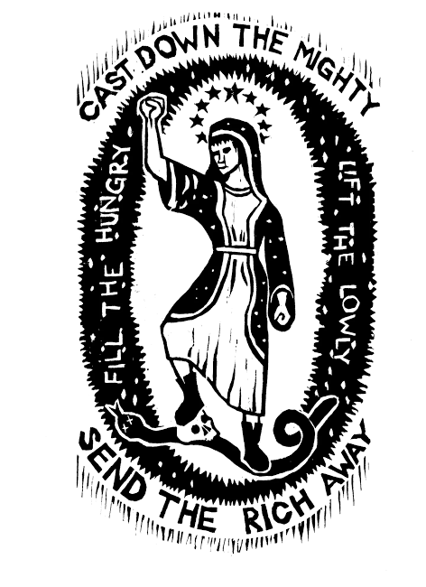
Fourth Sunday of Advent: Through Mary, a new king is coming who will reign with Justice
sets the scene for Luke’s emphasis on economic Reversal. See 3:10-14; 4:18-19; 6:20-26; 16:14-31
1 Samuel 2:1-10 Hannah prayed and said,
“My heart exults in the Lord;
my strength is exalted in my God.^{[a]}
My mouth derides my enemies
because I rejoice in your victory.
² There is no Holy One like the Lord,
no one besides you;
there is no Rock like our God.
³ Talk no more so very proudly;
let not arrogance come from your mouth,
for the Lord is a God of knowledge,
and by him actions are weighed.
⁴ The bows of the mighty are broken,
but the feeble gird on strength.
⁵ Those who were full have hired themselves out for bread,
but those who were hungry are fat with spoil.
The barren has borne seven,
but she who has many children is forlorn.
⁶ The Lord kills and brings to life;
he brings down to Sheol and raises up.
⁷ The Lord makes poor and makes rich;
he brings low; he also exalts.
⁸ He raises up the poor from the dust;
he lifts the needy from the ash heap
to make them sit with princes
and inherit a seat of honor.
For the pillars of the earth are the Lord’s,
and on them he has set the world.
⁹ He will guard the feet of his faithful ones,
but the wicked will perish in darkness,
for not by might does one prevail.
¹⁰ The Lord! His adversaries will be shattered;
the Most High^{[b]} will thunder in heaven.
The Lord will judge the ends of the earth;
he will give strength to his king
and exalt the power of his anointed.”

⁴⁶ And Mary^{[f]} said,
“My soul magnifies the Lord,
⁴⁷ and my spirit rejoices in God my Savior,
⁴⁸ for he has looked with favor on the lowly state of his servant.
Surely from now on all generations will call me blessed,
⁴⁹ for the Mighty One has done great things for me,
and holy is his name;
⁵⁰ indeed, his mercy is for those who fear him
from generation to generation.
⁵¹ He has shown strength with his arm;
he has scattered the proud in the imagination of their hearts.
⁵² He has brought down the powerful from their thrones
and lifted up the lowly;
⁵³ he has filled the hungry with good things
and sent the rich away empty.
⁵⁴ He has come to the aid of his child Israel,
in remembrance of his mercy,
⁵⁵ according to the promise he made to our ancestors,
to Abraham and to his descendants forever.”

Luke 1:46-55

